Grammar-oriented Object Design to Seamlessly Map Business Models to
Component -based Software Architectures,

Decorator for logging
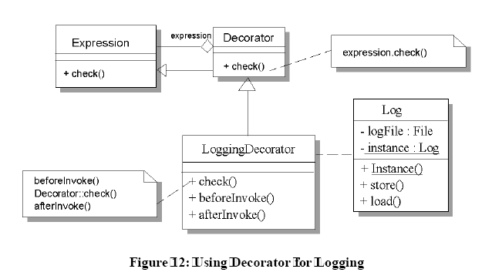

Observer for logging
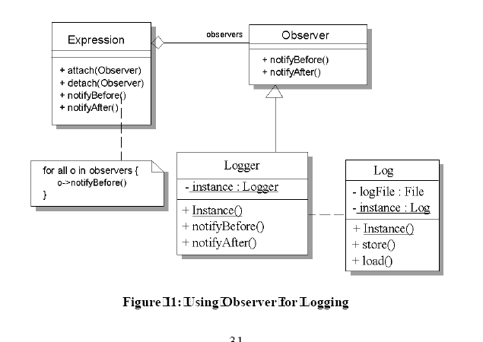
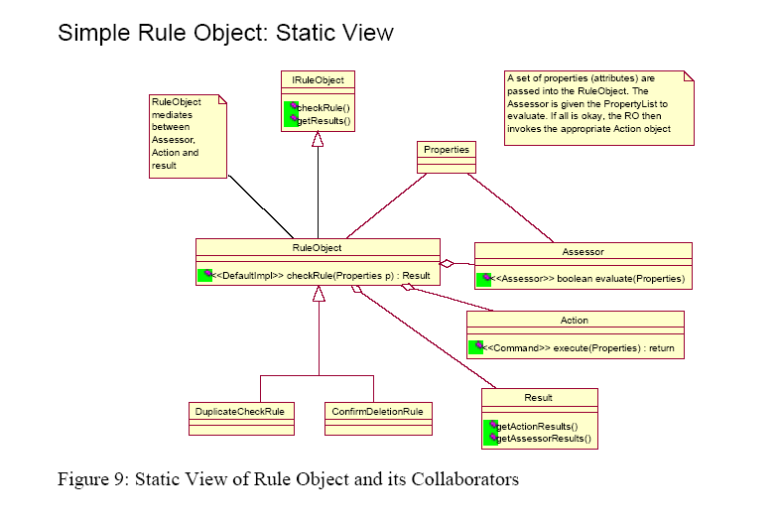

Compound Rule Object: Static View
The Rule Cluster holds a cluster of Composite Rules; each with their its potential Composite Conditions
and Actions. A Simple Rule is a leaf node of the composite and can exist by itself to handle (for example)
UI field editing and validation.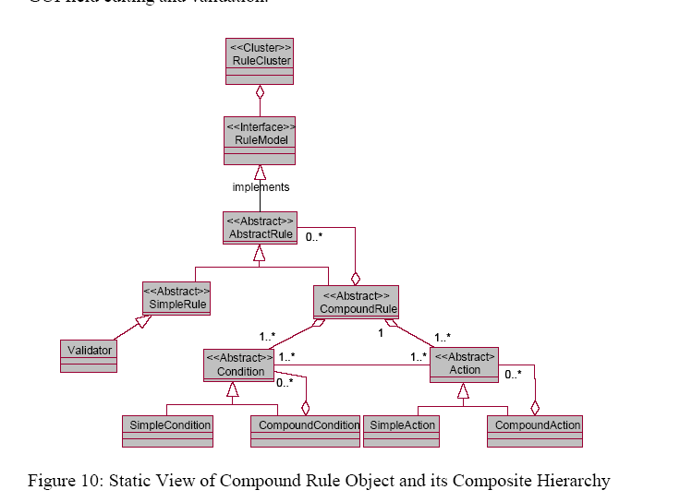
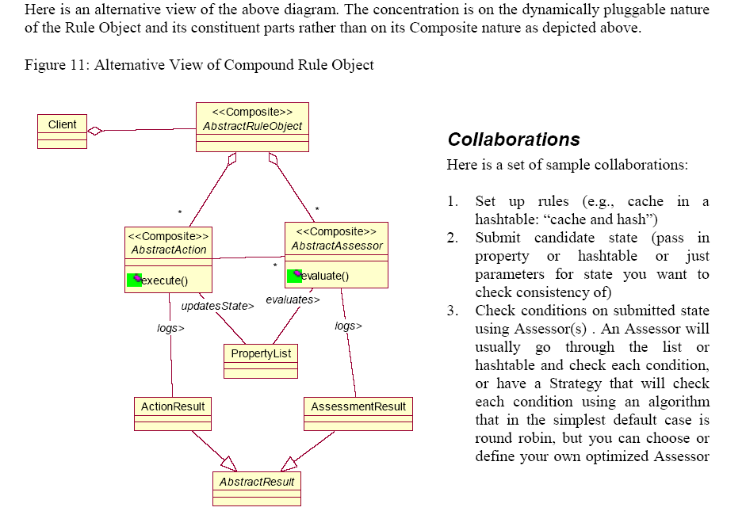
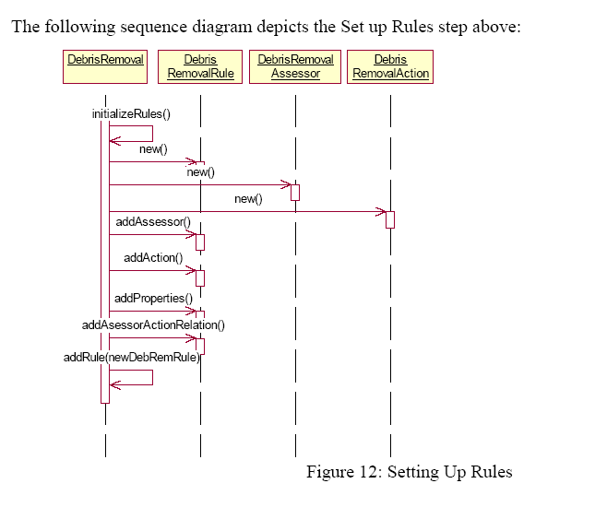

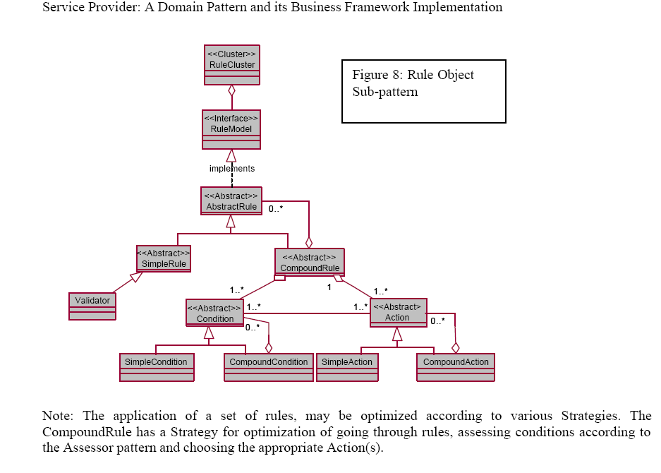

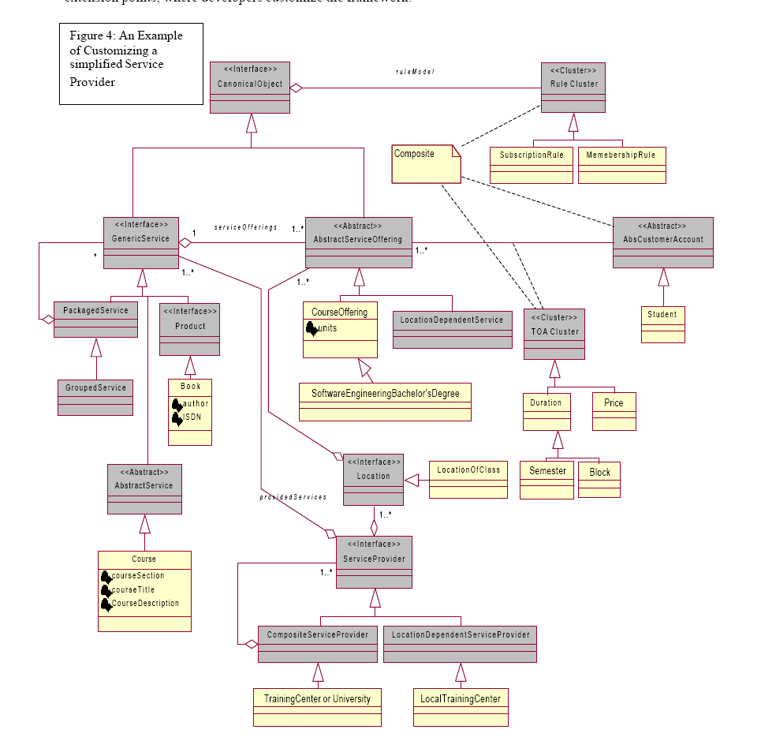

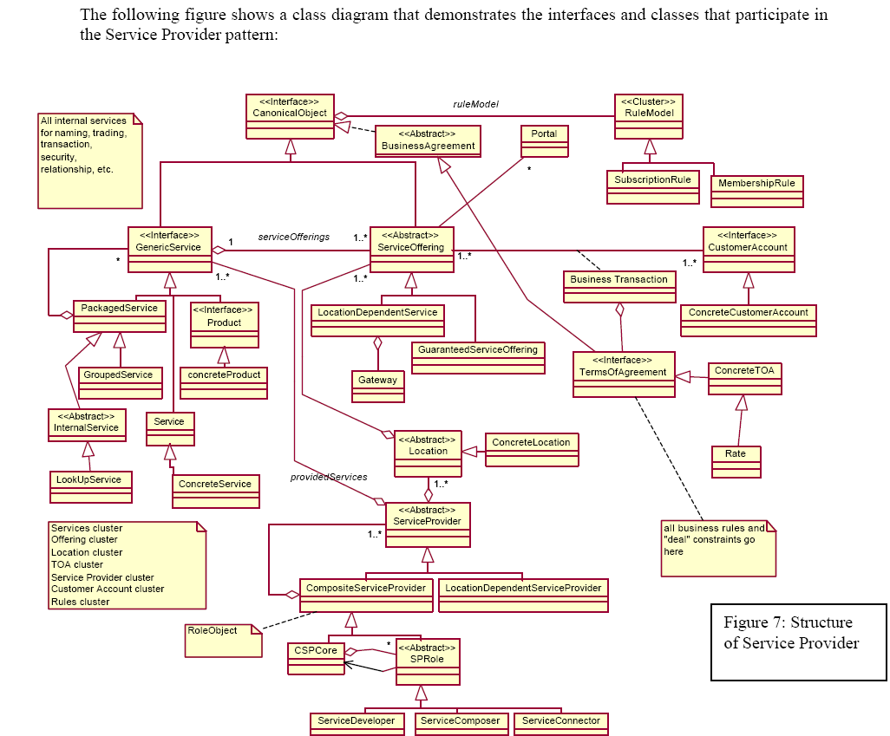

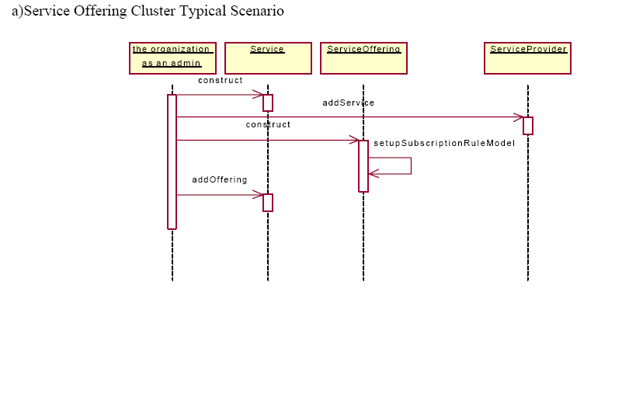
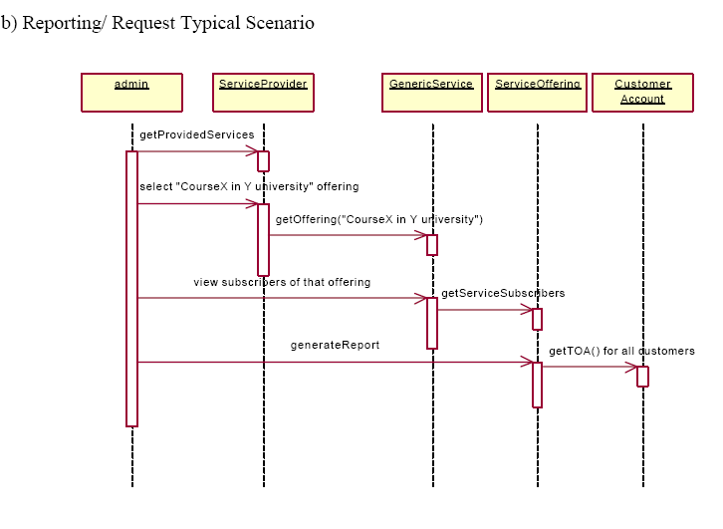

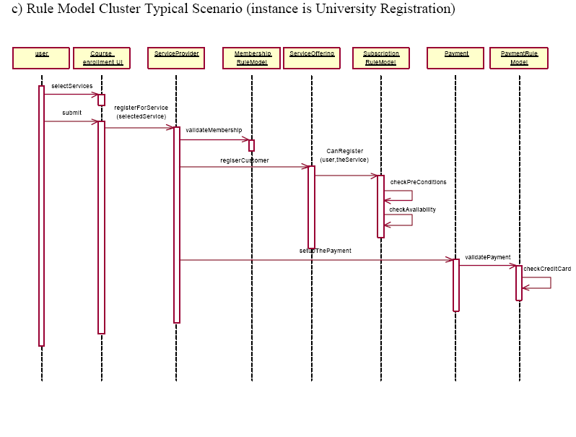

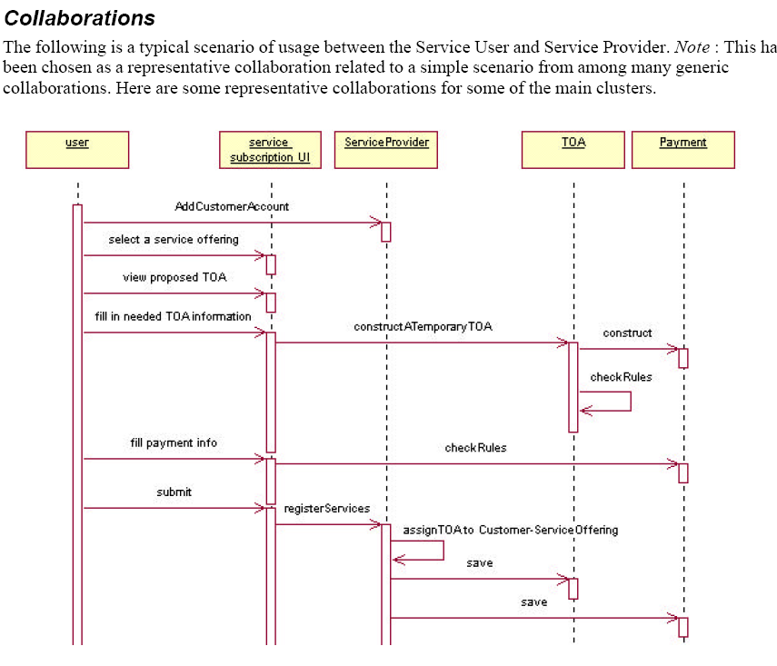

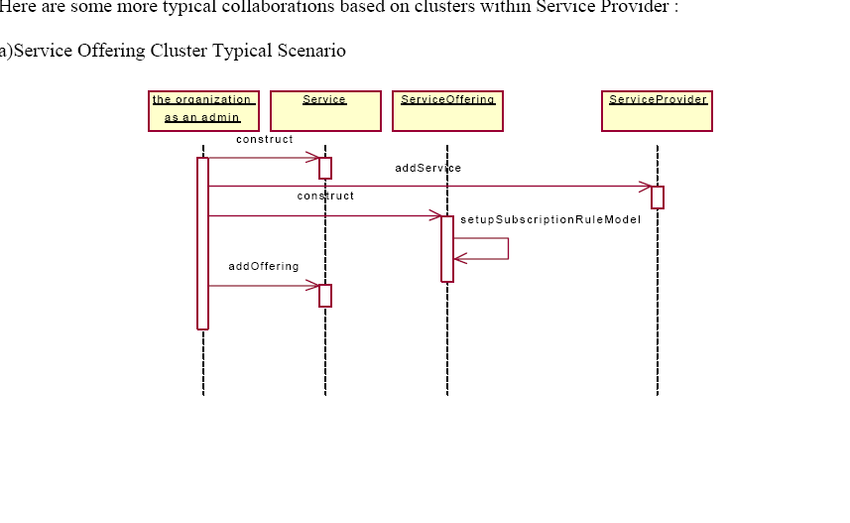

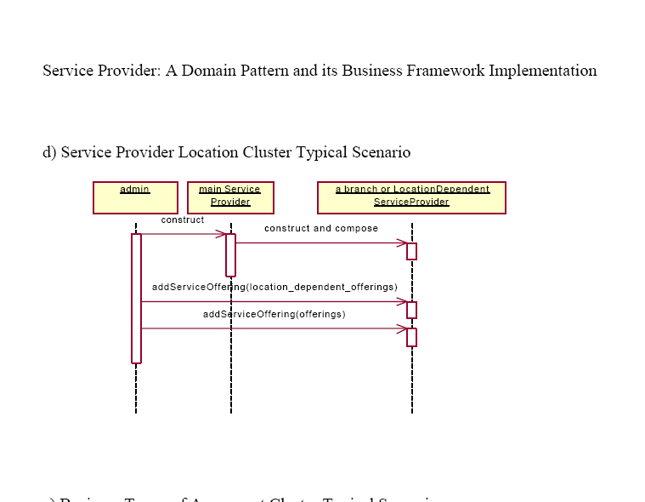

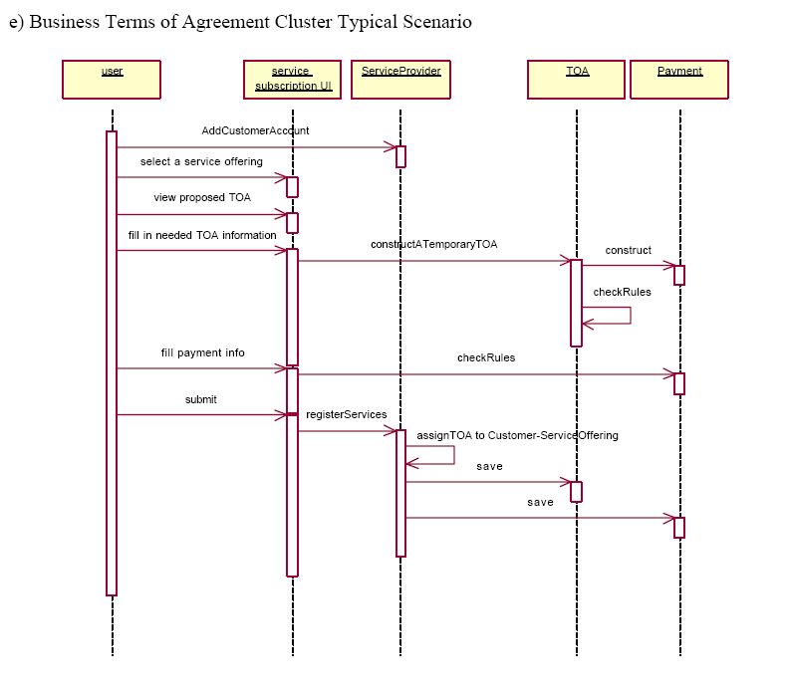

Appendix A: Rule Object: A Pattern Language for Adaptive and
Scalable Rule Design and Construction (Management)
The following table summarizes the patterns in this pattern language and provides an initial definition and
context for each one. The next section in this appendix outlines a map of the pattern language showing how
the patterns relate to one another; supplying transition criteria (for going from one pattern to another) and
the forces that will be encountered before the transition and once the transition is made.
Rule Pattern Language Summary
1. Rule Object –
You want to Provide extensibility and adaptability to business processes, without endangering them with
intrusive changes, by making the rules governing them pluggable. Therefore, externalize the rules during
design time. Separate the definition of the rules from the objects that are governed by those rules. Business
objects tend to participate in more than one configuration, collaboration and context. Therefore, avoid
statically binding a business object set to a given context by embedding the rules within it. Separate the
rules governing an object’s behavior from the object itself. Thus, you can re-define and re-configure how
the object should/will behave in new contexts and in the face of new requirements. For example, Define
new products and services based on the set of standard, atomic product and service types without stunting
the growth and resilience of the product definition process; geared to meet and overcome new demands of
clients, marketplace and competition.
2. Assessor – You want to check conditions that tend to vary a great deal. You don’t want to rewrite the
code every time, with a slightly novel twist. New requirements call for new assessment, evaluations,
based on which you take action; to accept an order, to submit a loan to register for a service based on
eligibility. Your conditions can be Boolean expressions or events that are guards in astate transition
diagram. Therefore, separate and reify the conditions from the action parts of a Rule. Assess a set of
conditions based on an input set of Properties (Context); record results of evaluations in a Result.
3. Action – You want to manage the changing set of actions you have to take when a condition has been
checked. It started out to be straightforward; but now there are multiple actions, each with a new twsit;
some are radically different. You want to avoid cluttering your code and want to be able to you’re your
actions in response to events or conditions rapidly. Therefore, separate and reify the action part of a
Rule from its condition part. Perform actions in continuation of the results of the Assessment of
conditions, record results and update Properties (Context; Context is Updated; Context is not Updated)
and State (Rule changes Object State; Rule maintains object State) of pertinent objects in
collaboration.
4. Rule Cluster – Components the Composite definition and application of Rule Objects; optimize rule
application through the definition and selection of a rule application policy.
5. Rules have State – Maintain State between rule checks and applications
6. Rules are Tracked – track history, changes, condition/action set pairs
7. Document Rules as Patterns—capture rules as patterns to track and report reasons for solution of
issues and consequences
8. Rule Object Repository: Centralize Rules in Corporate Repository
9. Rule Access Rights – managers should be able to create rules; give access rights to control unwanted
or accidental corruption of rules
10. Rules Change Process – New rules impact old processes
11. Components Have Manners – clusters of collaborating objects have laws governing their behavior
and meta-data about these rules (laws).
12. Rules as First-class Constructs -- conducting analysis and design based on object “manners”
13. Rules as Production Rules of the Application Domain Grammar – Grammar-oriented object design;
define a domain language and grammar for a domain; implement it using a parser accepting input from
an application running in that domain
14. Persistent Rules—Handle proliferation of subclasses and objects as “data”
15. Hash and Cache—provide efficient and quick access to subclasses and objects as the numbers
increase
© 1999-2001, Ali Arsanjani, IBM – Permission granted to make copies for the PLoP 2001 Conference 27
16. Remedy Rule Proliferation—Handle object proliferation syndrome
17. Rules Evolve – Rule evolution for business survival
18. Rule Change Impacts Architecture – information system architecture, functional and non-functional
requirements are impacted by changes in rules.
19. Rule Engine – The number of rules, their dependencies and potential conflicts are becoming
unmanageable. You have separated out the rules within the same program or you have externalized
them in a Configurable Profile or an External Rule, as an XML file or a EBNF-grammar. But now you
need to handle this additional complexity. Therefore, externalize the rules during run-time .
20. Rule Analysis: Add a phase in your development life-cycle to concentrate on sampling a subset of
business rules that form a representative picking of the population of your business rules across tiers
and business domains. Create a Rule Matrix showing dependencies and start isolating clusters of
dependencies that are cohesively as unit. Provide a solution for each cluster and place each cluster in
its appropriate place within the architecture using Rule Placement.

