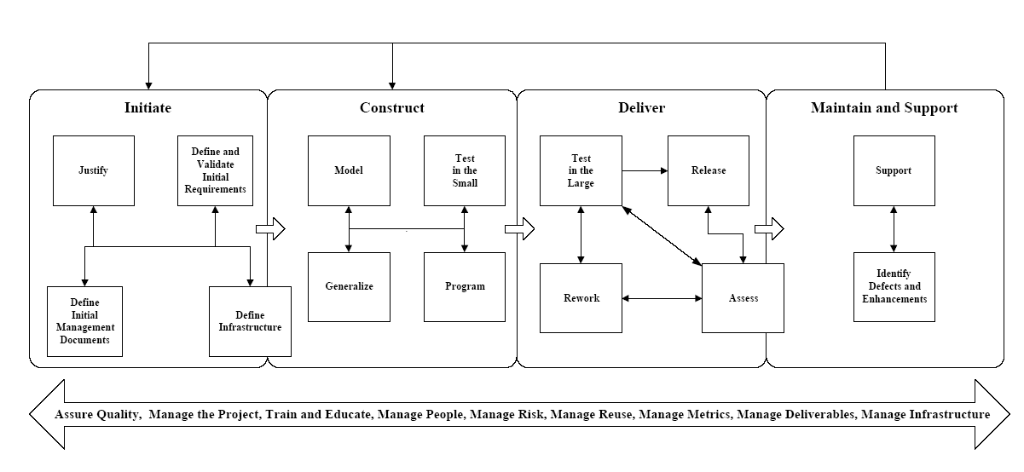

5. Phase Process Patterns
The main goal of the Construct phase, the second serial phase of the Object-Oriented Software Process
(OOSP) of Figure 4, is to build working software that is ready to be tested and delivered to your user
community. This software will be accompanied by the models and source code that was used to develop it,
a test plan to verify that the software works, any reusable artifacts that can be used on future projects, and
the initial documentation and training plans supporting the software.
5.1 Forces
There are several forces applicable to the Construct Phase, including a lack of understanding of how to
work the phase by both senior management and by developers; an unwarranted focus on programming to
the neglect of modeling, testing, and generalization; and a penchant by everyone involved to cut corners
and take shortcuts that more often than not result in poor quality software that is late and over budget
anyway.
5.2 Initial Context/Entry Conditions
The Construct phase can be entered two different ways, either from the Initiate phase or from the
Maintain and Support phase (see Figure 4). Regardless, there are several conditions that must be met
before the Construct phase may begin. First, the key project management documents (project plan,
estimate, schedule, risk assessment, …) should be available and up-to-date. Second, the project
infrastructure should be defined, or at least a good portion of it is defined, so that the tools, processes, and
standards are available to your development team. Third, the high-level requirements for your software
should be in place as well as the project charter for your team. Fourth, maintenance changes applicable to
the software you are constructing should be allocated to the release that you are working on (this is
applicable only for existing software that is being updated). Finally, your development team should be
selected and made available (as best as possible) for when they are needed by your project.
5.3 Solution
Figure 3 presents the Construct phase process pattern. An important implication of Figure 3 is that you
are not starting from scratch when you enter the Construct phase – important management documents
such as the project plan and initial risk assessment have been defined, the initial requirements for your
application should have been defined, the project infrastructure is (mostly) defined, and the funding and
charter for the project have been obtained. The four iterative stages of the Construct phase are highly
interrelated. The Model stage concentrates on the abstraction of the technical and/or problem domain via
the use of diagrams, documents, and prototypes. The Program stage (see Figure 2) focuses on the
development and documentation of program source code. The Generalize Stage is critical to your
organization’s reuse efforts as it focuses on identifying reusable items, or items that may become reusable
once modified, from a software project. This is effectively “opportunistic reuse” because you attempt to
develop reusable items by harvesting your work after the fact, instead of “systematic reuse” in which you
design software during modeling to be reusable. The goal of the Test In The Small Stage is to verify and
validate the deliverables developed by the other stages of the Construct Phase. In many ways this stage is
the equivalent of unit testing from the structured world combined with quality assurance techniques such
as code inspections and technical reviews.
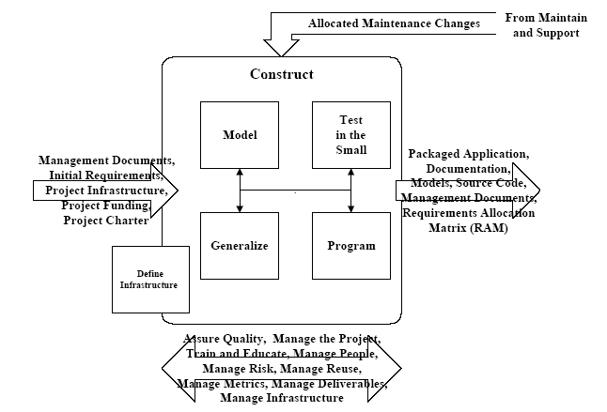
Figure 3. The Construct process pattern.
Just because the Construct Phase is iterative in nature, it DOES NOT imply that your developers are
allowed to start hacking. The reality of software development is that you must first identify and
understand the requirements for something, then you must model them, and then code them. If you have
not defined the requirements, then why are you building something? Do you honestly believe that it is
more productive for you to start writing code before investing the time to think about and to model what
you are building? Truly top-notch developers also know that they must verify their work before moving
on to the next task. There’s no value modeling requirements that are invalid, or writing source code based
on an incorrect model. This means that you need to test your work as you develop it, not at the end when
it is often too late to fix discovered problems. I’m not saying that you have to define all of the
requirements first, then do all of the modeling, then write all of the code. What I am saying is that any
code that you write should be based on a validated model, and that any modeling you do should be based
on one or more validated requirements.
5.4 Resulting Context/Exit Conditions
The Construct phase effectively ends when a code/development freeze has been declared. For a
code/development freeze to be official, the following deliverables must be in place (when applicable):
Models (Class Model, Use-Case Model, Sequence Diagrams, …), Requirements Allocation Matrix
(RAM), Source code, Master Test/QA Plan, User Documentation, Operations Documentation, Support
Documentation, the software itself, Training Plan, Release Plan, and Lessons Learned. At this point your
software is ready to move on to the Deliver phase (see Figure 4) where it will be tested in the large,
reworked as needed, and released to your user community.

