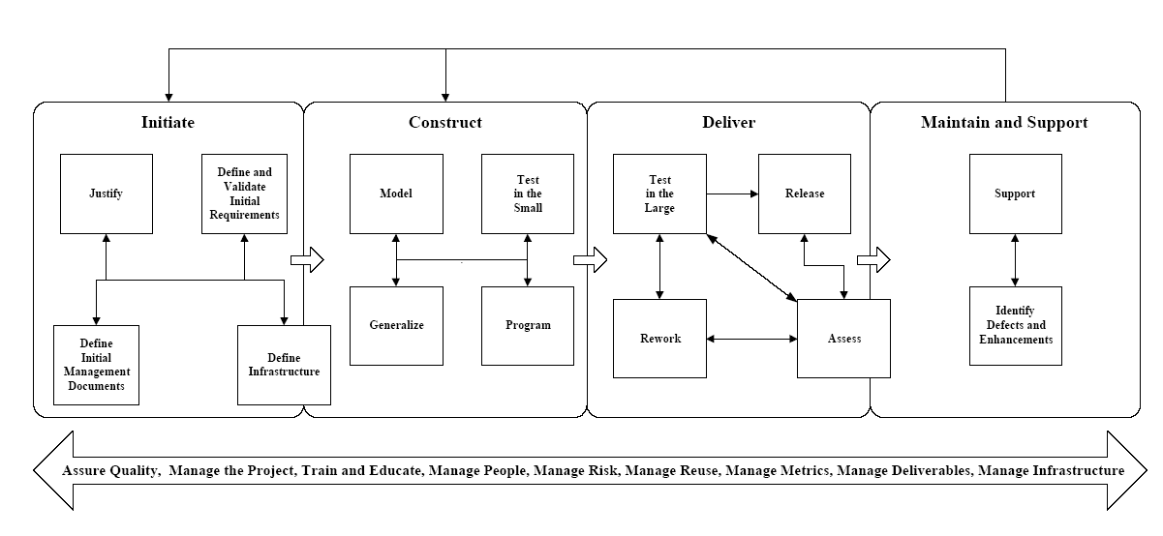

4. Stage Process Pattern – Program
An important aspect of software development, one of many to be exact, is the actual development of the
source code. As experienced developers know, there is far more to programming than just sitting down at
a computer and typing in source code. The Program stage process pattern describes the iterative
tasks/activities of programming.
4.1 Forces
Programmers need to develop software that meets the needs of their user communities, needs that have
been reflected in the form of models and documents developed during the Model stage and the Define and
Validate Initial Requirements stage (Ambler, 1998b). The developed source code should reflect the
information contained in these deliverables, yet at the same time may drive changes to them as
programmers gain a detailed understanding of the domain (usually more detailed than the modelers have).
Furthermore, most organizations want software to be developed in a timely and efficient manner but at the
same time want it to be maintainable and extensible so that changes in the future may be made efficiently
and quickly.
4.2 Initial Context/Entry Conditions
Several conditions must be met before coding may begin. First, your design models should be in place for
the code that you intend to write. Second, your project infrastructure should be in place, defined during
the Define Infrastructure stage of the Initiate phase (see Figure 4). The infrastructure includes the
development and supporting tools that your programmers will use as well as the standards and guidelines
that they will follow. Third, programmers must be available to do the work.
4.3 Solution
Figure 2 depicts the process pattern for the Program stage, showing that there is more to this stage than
simply writing source code: you need to understand the models, then seek out reusable artifacts to reduce
your work load, then document what you are going to write, then write the code, then inspect and improve
it, then test and fix it, and then finally package it.
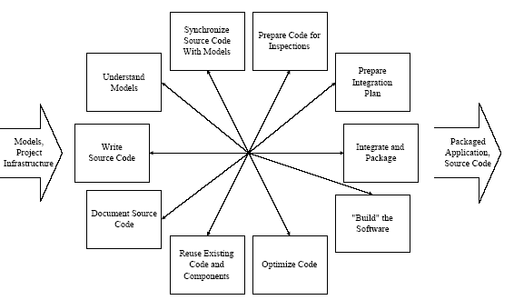

Figure 2. The Program process pattern.
The very first thing that should occur before coding begins is that programmers must take the time to
understand the models that define what they are to build. Although this sounds straightforward and
obvious, it very often is not done. If programmers do not take the time to understand the model before they
begin coding, then why bother creating the models in the first place (ideally the programmers were
involved in the development of the design models)? The goal is for programmers to understand the design
issues and trade-offs involved, and how their code will fit into the overall application. They must invest
the time to understand both the problem and the solution before they write the code.
Once your programmers have taken the time to review the models and to understand what needs to be
built, they should then look to see what has already been built. One of the promises of object-oriented
development is that of increased reuse, but you need to recognize the fact that you can only increase reuse
on your projects if you choose to do so. This means that somebody has to make an effort to reuse existing
artifacts, and the best way to do so is to look for reusable artifacts before you start writing code. Your
design should have also considered reuse issues.
Before you write your source code, you should first document it. Although this seems non-intuitive at first,
experience shows that programmers who start by writing brief comments that describe their coding logic
are significantly more productive than programmers who do not. The reason for this is simple: the hard
part about programming is getting the logic right, not writing the actual code that implements that logic.
Writing source code before documenting it is a common process ant pattern, one that you want to avoid if
possible. By documenting your logic first in the form of brief comments, also called pseudo code, you
invest the time to get your logic in place, avoiding the problem of writing a lot of code that later needs to
be scrapped because it does not work right. Think first, then code.
Once programmers have invested the time to understand the models that they are implementing, searched
for reusable components to reduce their workload, and then written at least initial documentation for their
code, they are ready to actually begin writing object-oriented source code. The code that is written should
conform to the standards and guidelines defined and selected for your project – conformance that will be
verified by code reviews.
Throughout the coding process programmers must constantly take the time to synchronize their source
code with the model. During coding it often becomes clear that the models/documentation doe not include
all of the information needed by the coder. If this is the case, then the coder should first talk to the
modeler to determine a solution, and then both the model(s) and the code should be updated to reflect the
solution. The important thing is that the code reflects the information contained in the models and vice
versa.
The source code produced by a development team will be inspected, in whole or in part, as part of the Test
in the Small stage (Ambler, 1998b). To prepare for a code review, which will apply the Technical Review
task process pattern, a programmer should be reasonably assured that their code will pass inspection. This
means that the code satisfies the design, follows standards, is well documented, is easy to understand, and
is well written.
My experience is that you want to leave optimization to the end because you want to optimize only the
code that needs it: very often a small percentage of your code results in the vast majority of the processing
time, and this is the code that you should be optimizing. A classic mistake made by inexperienced
programmers it to try to optimize all of their code, even code that already runs fast enough. Personally, I
prefer to optimize the code that needs it and then move on to more interesting things than trying to
squeeze out every single CPU cycle.
Creating a build is the act of compiling and linking your source code in compiled languages such as Java
and C++, or packaging your code in languages like Smalltalk. As you would expect, you use tools called
compilers, linkers, and packagers to create a build, which I will refer to as “builders” for the sake of our
discussion. Successful builds produce software that can be run and tested, whereas unsuccessful builds
produce an indication of what your builder did not like about your code. Builds are important because they
help to find integration problems in your code; if your code does not integrate well, it will likely break
your build, and the build shows that your code does in fact compile – often an incredible morale booster
for your programming team.
Long before you attempt to integrate and package your application you must first have a plan to do so.
Three key deliverables are needed by the developers responsible for integrating and packaging your
application: an integration plan that describes the schedule, resources, and approach to integrating the
elements of an application, a version description document (VDD) that describes the elements of an
application and their interrelationships, and a deployment diagram that shows how the software will be
deployed to the user community. To integrate and package your application, you must build and smoketest
your software, produce the supporting documentation, and develop the installation process for your
software. If you perform daily builds, then the first step is straightforward, as you merely need to follow
your existing build procedure to gather and then build the source code files that make up your application.
4.4 Resulting Context/Exit Conditions
The following conditions must be met before the Program stage may be considered complete. First, your
code should have passed inspection. Second, the code should work (it passed testing). Third, the code
should have been optimized sufficiently. Fourth, if applicable the software should be integrated and
packaged for delivery.

