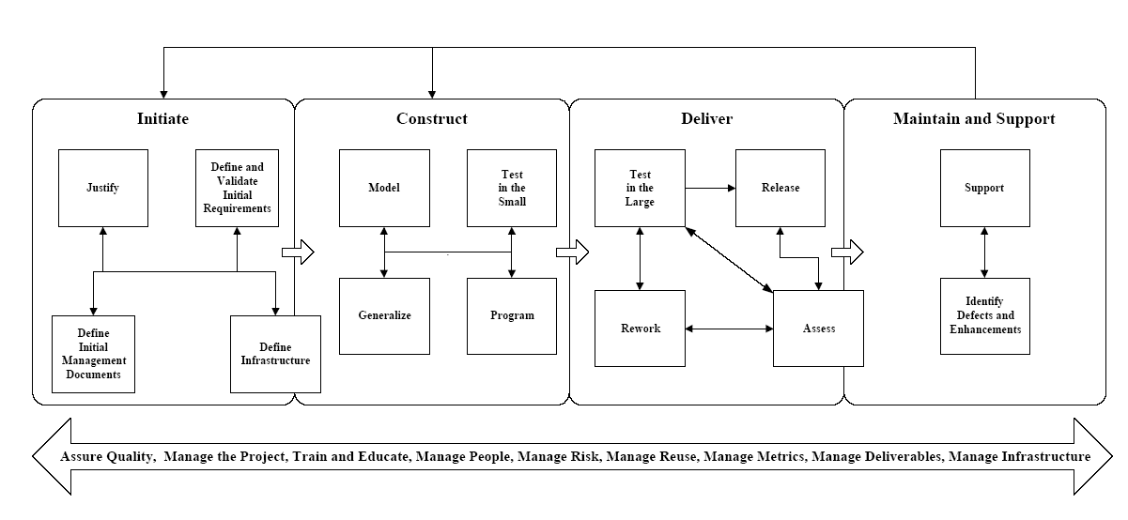
3. Task Process Pattern – Technical Review
The deliverables created during development need to be validated to ensure that they meet the needs of
your user community and the quality standards of your organization. The Technical Review task process
pattern describes how to organize, conduct, and follow through on the review of one or more deliverables.
This pattern is of the same theme as the Validation by Teams (Harrison, 1996), Review (Coplien, 1995),
Creator-Reviewer (Weir, 1998), and Group Validation (Coplien, 1995) task process patterns.
3.1 Forces
There are several applicable forces motivating the Technical Review process pattern. First, the
deliverables (models, prototypes, documents, source code, …) produced during the development process
help to define the software and related products to be released to your user community, therefore you
should validate that each deliverable is of sufficient quality before building on it. Second, because the cost
of fixing defects increases the later they are detected in the development life cycle (Ambler, 1998a) as a
result of the error snowballing throughout your work, you want to detect defects as early as possible so you
may fix them early (and inexpensively). Third, because it is difficult to review your own work you want
“a second set of eyes” to review a deliverable. Fourth, you want to communicate your work to others, and
one way to do that is to have your teammates review the deliverables that you produce.
3.2 Initial Context
There are one or more deliverables to be reviewed, the deliverables are ready to be reviewed, and the
development team is ready to have the deliverables reviewed.
3.3 Solution
Figure 1 shows that there are six basic steps to the Technical Review process pattern (model reviews,
document reviews, prototype reviews, requirement reviews, and code inspections are all specific processes
that follow the Technical Review process pattern). The steps of a technical review are as follows:
1. The development team prepares for review. The item(s) that are to be reviewed are gathered,
organized appropriately, and packaged so that they may be presented to the reviewers.
2. The development team indicates that they are ready for review. The development team must
inform the review manager, often a member of quality assurance, when they are ready to have
their work reviewed as well as what they intend to have reviewed.
3. The review manager performs a cursory review. The first thing that the review manager must
do is determine if the development team has produced work that is ready to be reviewed. The
manager will probably discuss the development team’s work with the team leader and do a quick
rundown of what they have produced. The main goal is to ensure that the work to be reviewed is
good enough to warrant getting a review team together.
4. The review manager plans and organizes the review. The review manager must schedule a
review room and any equipment needed for the review, invite the proper people, and distribute
any materials ahead of time that are needed for the review. The potential contents of a review
package are discussed in the next section.
5. The review takes place. Technical reviews can take anywhere from several hours to several
days, depending on the size of what is being reviewed, although the best reviews are less than
two hours so as not to overwhelm the people involved. The entire development team should
attend, or at least the people responsible for what is being reviewed, to answer questions and to
explain/clarify their work. There are typically between three to five reviewers, as well as the
review manager, all of whom are responsible for doing the review. It is important that all
material is reviewed. It is too easy to look at something quickly and assume that it is right. It is
the job of the review facilitator to ensure that everything is looked at, that everything is
questioned.
The review results are acted on. A document is produced during the review describing both the
strengths and weaknesses of the work being reviewed. This document should provide both a
description of any weakness, why it is a weakness, and provide an indication of what needs to be
addressed to fix the weakness. This document will be given to the development team so that they
can act on it, and to the review manager to be used in follow-up reviews in which the work is
inspected again to verify that the weaknesses were addressed.

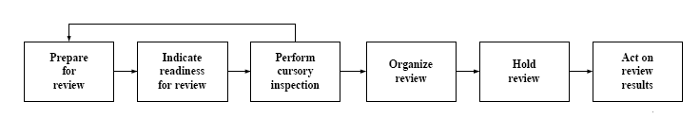
Figure 1. The Technical Review process pattern.
3.4 Resulting Context
Senior management is assured that the development team has produced quality deliverables that meet the
needs of their user community. The development team, and the reviewers, have a better understanding of
the deliverables that they are building and how their work fits into the overall software project. Individual
team members and reviewers are likely to learn new techniques during the review, either techniques
applied to the deliverable itself, management techniques applied during the review, or development
techniques suggested during the review to improve the deliverable.

