Broker
Version 1.0.1
GotDotNet community for collaboration on this pattern
Complete List of patterns & practices

Context
Many complex software systems run on multiple processors or distributed computers. There are a number of reasons to distribute software across computers, for example:
• A distributed system can take advantage of the computing power of multiple CPUs or a cluster of low-cost computers.
• Certain software may only be available on specific computers.
• Parts of the software may have to run on different network segments due to security considerations.
• Some services may be provided by business partners and may only be accessed over the Internet.
However, implementing a distributed system is not easy because you have to deal with issues such as concurrency, cross-platform connectivity, and unreliable network connections.

Problem
How can you structure a distributed system so that application developers don't have to concern themselves with the details of remote communication?

Forces
The following forces must be reconciled as you build a distributed system:
• Although distributed systems provide a lot of advantages, they also tend to introduce significant complexity into the software system. Physical and logic boundaries exist between processes or computers running on the same network. To have objects running on different processes or computers communicating with each other across these boundaries, you have to deal with issues such as communications, encoding, and security. If you mix these implementation details with the application code, a simple change in the communications infrastructure could lead to significant code changes.
• The distribution of the system often occurs after development is complete. For example, software may be distributed across multiple servers to increase processing power. You would not want to change the application code at this late a stage in the life cycle.
• The details of cross-process communication can be quite tedious. You have to deal with TCP/IP sockets, marshaling and unmarshaling, serialization, timeouts, and many other challenges. Therefore, it makes sense to have a special team focus on the infrastructure so that the application developers do not have to learn about remote communications.
• To maintain the flexibility of being able to move components to different locations at deployment time, you must avoid hard-coding the location of specific components.

Solution
Use the Broker pattern to hide the implementation details of remote service invocation by encapsulating them into a layer other than the business component itself [Buschmann96].
This layer provides an interface to the client that allows it to invoke methods just as it would invoke any local interface. However, the methods inside the client interface trigger services to be performed on remote objects. This is transparent to the client because the remote service object implements the same interface. This pattern refers to the business component that initiates the remote service invocation as the client, and the component that responds to the remote service invocation as the server.
Figure 1 shows the static structure of a simple example without any distribution. The client invokes the performFunctionA method on the server directly. This is possible only if the server objects reside on the same computer as the client objects.
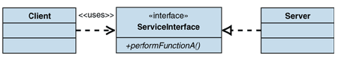
Figure 1: Structure with no distribution
Figure 2 shows the static structure when distribution is implemented.
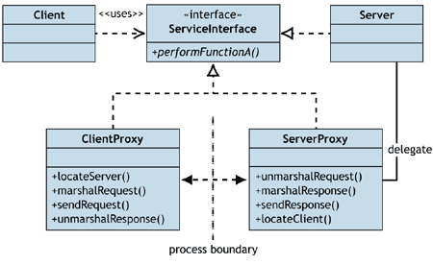
Figure 2: Structure with distribution
The ServiceInterface is a necessary abstraction that makes distribution possible by providing the contract about the service that the server is going to provide without exposing the implementation details on the server side. When implementing the distribution, client and server proxies would be added to handle all the "plumbing" for sending a method invocation and its parameters across the network to the server and then sending the response back to the client. The proxies would do all the marshaling and unmarshaling of data, security control, transfer channel configuration, and any other additional work. The client would simply invoke the performFunctionA method on the client proxy as if it were a local call because the client proxy actually implements the ServerInterface. The code change to the client would be minimal and thus you could develop your whole business domain model without any knowledge about the distribution nature of the system. Any change to the way remote service invocation is implemented would be limited to within the proxy classes, and would not have any impact on the domain model. Figure 3 shows one scenario of the interactions between these components.
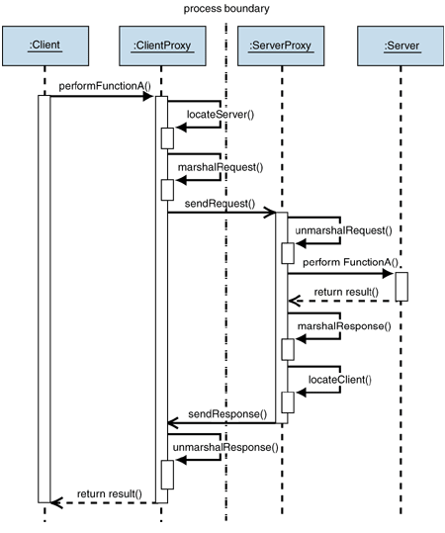
Figure 3: Behavior with distribution

Server Look-Up
The Broker solution addresses most of the problems described previously. However, because the client proxy communicates with the server proxy directly, the client must be able to find the location of the server at compile time. This means that you cannot change or move the server to a different location at run time. To overcome this limitation, you need to avoid exposing the exact location of the server. Instead, you deploy a new component, the broker component, at a well-known location and then expose that location to the client. The broker component is then responsible for locating the server for the client. The broker component also implements a repository for adding and removing server components, which makes it possible to add, remove, or exchange server components at run time. Figure 4 shows the static structure with the broker component involved.
This type of function is often called a naming service. Looking up remote objects is a common requirement in enterprise computing. Therefore, a number of platforms implement a naming service, for example, Microsoft uses the Active Directory directory service.
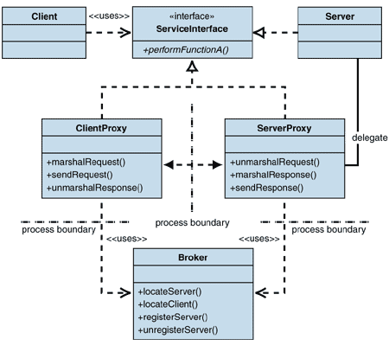
Figure 4: Broker structure with server look-up
The broker is hosted at a well-known location that should not change very often. Any server that is activated and ready to receive requests would register itself with the broker so that the next time a client asks the broker for this type of server, the broker would be able to use it. This could also increase the performance and availability of the system, because it enables you to have multiple identical server components that run and serve multiple clients at the same time. This mechanism is sometimes called load balancing. Figure 5 shows a sample interaction scenario between these components.
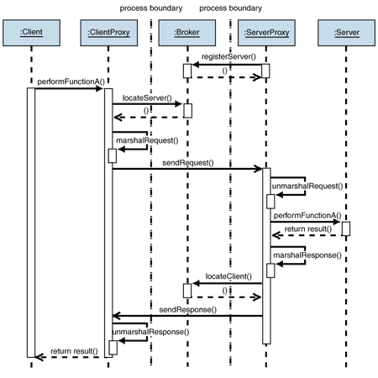
Figure 5: Broker behavior with server look-up

Broker as Intermediary
In the previous scenario, the broker is only responsible for locating the server for the client. The client obtains the location of the server from the broker and then communicates with the server directly without any involvement of the broker. In some situations, however, direct communication between client and server is not desirable. For example, for security reasons, you may want to host all the servers in your company's private network, which is behind a firewall, and only allow access to them from the broker. In this case, you must have the broker forward all the requests and responses between the server and the client instead of having them talk to each other directly. Figure 6 shows a revised static structure of this model.
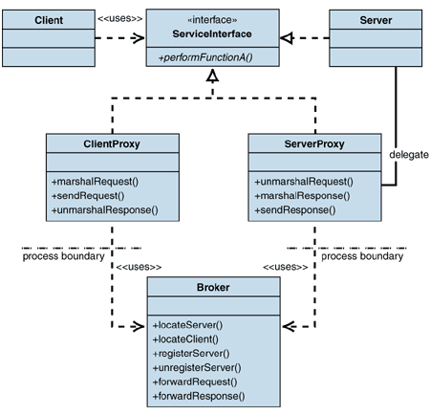
Figure 6: Structure of Broker serving as intermediary
Figure 7 shows the interaction diagram with the broker serving as a messenger between the client and the server. This example also shows how the communication between the client and the server can be asynchronous (note the open arrowhead on the sendRequest call).
There are also situations when the client must make a series of method invocations on the same server to complete one long and complex business transaction. In these cases, the server must maintain the state between client calls. The broker must then make sure that all server calls that a client makes inside an atomic session are routed to the exact same server component.
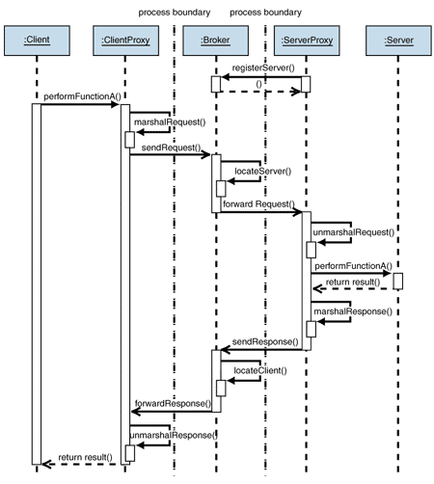
Figure 7: Behavior of Broker serving as intermediary

Example
The Broker pattern and its variants are implemented in many distributed system frameworks. See Implementing Broker in .NET Remoting Using Server-Activated Objects and Implementing Broker in .NET Remoting Using Client-Activated Objects.

Resulting Context
The Broker pattern has many of the benefits and liabilities of the Layered Application pattern.

Benefits
Broker provides the following benefits:
• Isolation. Separating all the communication-related code into its own layer isolates it from the application. You can decide to run the application distributed or all on one computer without having to change any application code.
• Simplicity. Encapsulating complex communication logic into a separate layer breaks down the problem space. The engineers coding the broker do not have to concern themselves with arcane user requirements and business logic, and the application developers do not have to concern themselves with multicast protocols and TCP/IP routing.
• Flexibility. Encapsulating functions in a layer allows you to swap this layer with a different implementation. For example, you can switch from DCOM to .NET remoting to standard Web services without affecting the application code.

Liabilities
Unfortunately, layers of abstraction can harm performance. The basic rule is that the more information you have, the better you can optimize. Using a separate broker layer may hide details about how the application uses the lower layer, which may in turn prevent the lower layer from performing specific optimizations. For example, when you use TCP/IP, the routing protocol has no idea what is being routed. Therefore, it is hard to decide that a packet containing a video stream, for instance, should have routing priority over a packet containing a junk e-mail.

Security Considerations
Server components that contain sensitive business data are often located in a company's private network, protected behind a firewall. The broker component then sits in a perimeter network (also known as demilitarized zone, DMZ, or screened subnet), which is a small network inserted as a neutral zone between a company's private network and the outside public network. Access to the server components is only allowed from the perimeter network and not from the outside public network. This extra layer prevents outside users from getting direct access to a server.

Related Patterns
For more information about Broker, see the following related patterns:
• Implementing Broker with .NET Remoting Using Server-Activated Objects and Implementing Broker with .NET Remoting Using Client-Activated Objects describe two implementation strategies for the Broker pattern.
• Data Transfer Object.
• Remote Proxy. The ClientProxy object described in this pattern follows a variant of the Proxy pattern described in [Gamma95, Buschmann96], which is called Remote Proxy.

Acknowledgments
[Buschmann96] Buschmann, Frank, et al. Pattern-Oriented Software Architecture. John Wiley & Sons Ltd, 1996.
[Fowler03] Fowler, Martin. Patterns of Enterprise Application Architecture. Addison-Wesley, 2003.
[Gamma95] Gamma, Helm, Johnson, and Vlissides. Design Patterns: Elements of Reusable Object-Oriented Software. Addison-Wesley, 1995.

