Observer
Version 1.0.1
GotDotNet community for collaboration on this pattern
Complete List of patterns & practices

Context
In object-oriented programming, objects contain both data and behavior that, together, represent a specific aspect of the business domain. One advantage of using objects to build applications is that all manipulation of the data can be encapsulated inside the object. This makes the object self-contained and increases the potential for reuse of the object in other applications. However, objects cannot simply work in isolation. In all but the most trivial applications, objects must collaborate to accomplish more complex tasks. When objects collaborate, the objects may have to notify each other when an object changes state. For example, the Model-View-Controller pattern prescribes the separation of business data (the model) and the presentation logic (the view). When the model changes, the system must notify the view so that it can refresh the visual presentation and accurately reflect the model's state. In other words, the view is dependent on the model to inform it of changes to the model's internal state.

Problem
How can an object notify other objects of state changes without being dependent on their classes?

Forces
A solution to this problem has to reconcile the following forces and considerations:
• The easiest way to inform dependent objects of a state change is to call them directly. However, direct collaboration between objects creates dependency between their classes. For example, if the model object calls the view object to inform it of changes, the model class is now also dependent on the view class. This kind of direct coupling between two objects (also called tight coupling) decreases the reusability of classes. For example, whenever you want to reuse the model class, you have to also reuse the view class because the model makes calls to it. If you have more than one view, the problem is compounded.
• The need to decouple classes occurs frequently in event-driven frameworks. The framework must be able to notify the application of events, but the framework cannot be dependent on specific application classes.
• Likewise, if you make a change to the view class, the model is likely to be affected. Applications that contain many tightly coupled classes tend to be brittle and difficult to maintain, because changes in one class could affect all the tightly coupled classes.
• If you call the dependent objects directly, every time a new dependent is added, the code inside the source object has to be modified.
• In some cases, the number of dependent objects may be unknown at design time. For example, if you allow the user to open multiple windows (views) for a specific model, you will have to update multiple views when the model state changes.
• A direct function call is still the most efficient way to pass information between two objects (second only to having the functionality of both objects inside a single object). As a result, decoupling objects with other mechanisms is likely to adversely affect performance. Depending on the performance requirements of the application, you may have to consider this tradeoff.

Solution
Use the Observer pattern to maintain a list of interested dependents (observers) in a separate object (the subject). Have all individual observers implement a common Observer interface to eliminate direct dependencies between the subject and the dependent objects (see Figure 1).
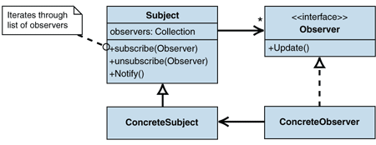
Figure 1: Basic Observer structure
When a state change occurs in the client that is relevant to the dependent objects, ConcreteSubject invokes the Notify() method. The Subject superclass maintains a list of all interested observers so that the Notify() method can loop through the list of all observers and invoke the Update() method on each registered observer. The observers register and unregister for updates by calling the subscribe() and unsubscribe() methods on Subject (see Figure 2). One or more instances of ConcreteObserver may also access ConcreteSubject for more information and therefore usually depend on the ConcreteSubject class. However, as Figure 1 illustrates, there is no direct or indirect dependency from the ConcreteSubject class on the ConcreteObserver class.
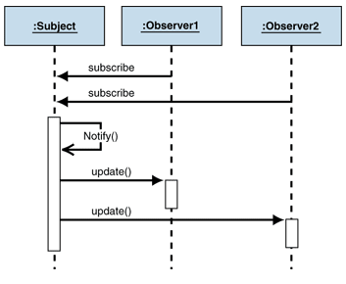
Figure 2: Basic Observer interaction
With this generic way of communicating between the subject and observers, collaborations can be built dynamically instead of statically. Due to the separation of notification logic and synchronization logic, new observers can be added without modifying the notification logic, and notification logic can also be changed without affecting the synchronization logic in observers. The code is now much more separate, and thus easier to maintain and reuse.
Notifying objects of changes without incurring a dependency on their classes is such a common requirement that some platforms provide language features to perform this function. For example, the Microsoft .NET Framework defines the notion of delegates and events to accomplish the Observer role. Therefore, you would rarely implement the Observer pattern explicitly in .NET, but should use delegates and events instead. Most .NET developers will think of the Observer pattern as a complicated way to implement events.
The solution presented in Figure 1 shows the ConcreteSubject class inheriting from the Subject class. The Subject class contains the implementations of the methods to add or remove observers and to iterate through the list of observers. All ConcreteSubject has to do is to inherit from Subject and call Notify() when a state change occurs. In languages that only support single inheritance (such as Java or C#), inheriting from Subject precludes the class from inheriting from any other class. This can be a problem because in many cases ConcreteSubject is a domain object that may inherit from a domain object base class. Therefore, it is a better idea to replace the Subject class with a Subject interface and to provide a helper class for the implementation (see Figure 3). This way, you do not exhaust your single superclass relationship with the Subject class but can use the ConcreteSubject in another inheritance hierarchy. Some languages (for example, Smalltalk) even implement the Subject interface as part of the Objectclass, from which every class inherits implicitly.
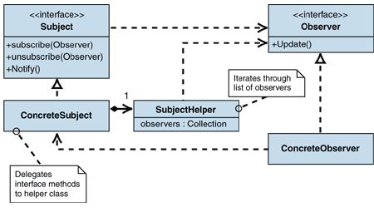
Figure 3: Using a helper class to avoid inheriting from the Subject class
Unfortunately, you now have to add code to each class that inherits from the Subject interface to implement the methods defined in the interface. This task can become very repetitious. Also, because the domain object coincides with ConcreteSubject, it cannot differentiate between different types of state changes that would be associated with different subjects. This only allows observers to subscribe to all state changes of ConcreteSubject, even though you may want to be more selective (for example, if the source object contains a list, you may want to be notified of updates, but not of insertions). You could have the observers filter out notifications that are not relevant, but that makes the solution less efficient, because ConcreteSubject calls all the observers just to find out that they are really not interested.
You can resolve these issues by separating the subject completely from the source class (see Figure 4). Doing so reduces ConcreteSubject to the implementation of the Subject interface; it has no other responsibilities. This allows DomainObject to be associated with more than one ConcreteSubject so that you can differentiate between different types of events for a single domain class.
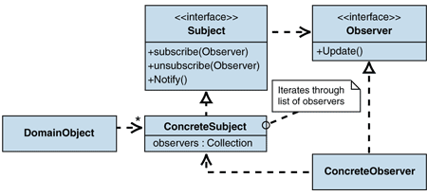
Figure 4: Separating DomainObject and Subject
The event and delegate features in the .NET Framework implement this approach as a language construct so that you do not even have to implement your own ConcreteSubject classes anymore. Basically, events replace the ConcreteSubject classes, and delegates implement the role of the Observer interface.

Propagating State Information
So far, this solution has described how a client object can notify the observers when a state change occurs, but has not yet discussed how the observers find out which state the client object is in. There are two mechanisms for passing this information to the observers:
• Push model. In the push model, the client sends all relevant information regarding the state change to the subject, which passes the information on to each observer. If the information is passed in a neutral format (for example, XML), this model keeps the dependent observers from having to access the client directly for more information. On the other hand, the subject has to make some assumptions about which information is relevant to the observers. If a new observer is added, the subject may have to publish additional information required by that observer. This would make the subject and the client once again dependent on the observers - the problem you were trying to solve in the first place. So when using the push model, you should err on the side of inclusion when determining the amount of information to pass to the observers. In many cases, you would include a reference to the subject in the call to the observer. The observers can use that reference to obtain state information.
• Pull model. In the pull model, the client notifies the subject of a state change. After the observers receive notification, they access the subject or the client for additional data (see Figure 5) by using a getState() method. This model does not require the subject to pass any information along with the update() method, but it may require that the observer call getState() just to figure out that the state change was not relevant. As a result, this model can be a little more inefficient. Another possible complication occurs when the observer and the subject run in different threads (for example, if you use RMI to notify the observers). In this scenario, the internal state of the subject may have changed again by the time the observer obtains the state information through the callback. This may cause the observer to skip an operation.
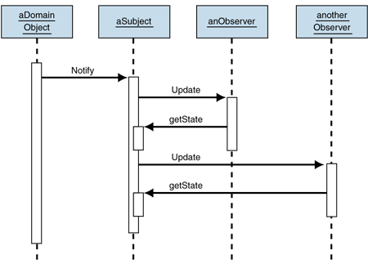
Figure 5: State propagation using the pull model

When to Trigger an Update
When implementing the Observer pattern, you have two options for managing the triggering of the update. The first option is to insert the call to Notify() in the client right after each call to Subject that affects an internal state change. This gives the client full control over the frequency of the notification, but also adds extra responsibility to the client, which can lead to errors if the developer forgets to call Notify(). The other choice is to encapsulate the call to Notify() inside each state-changing operation of Subject. This way, a state change always causes Notify() to be called without additional action from the client. The downside is that several nested operations might cause multiple notifications. Figure 6 shows an example of this in which Operation A calls Sub-Operation B and an observer might receive two calls to its Update method.
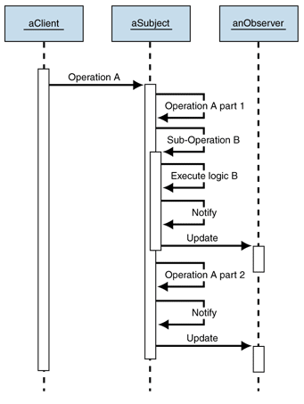
Figure 6: Extraneous notifications
Calling multiple updates for a single, but nested operation can cause some inefficiency, but also leads to more serious side effects: The subject could be in an invalid state when the nested Notify method is invoked at the end of Operation B (see Figure 6) because Operation A has only been processed part of the way. In this case, the nested notify should be avoided. For example, Operation B can be extracted out into a method without notification logic and can rely on the call to Notify() inside Operation A. Template Method [Gamma95] is a useful construct for making sure the observers are notified only once.

Observers Affecting State Change
In some cases, an observer may change the state of the subject while it is processing the update() call. This could lead to problems if the subject automatically calls Notify() after each state change. Figure 7 shows why.
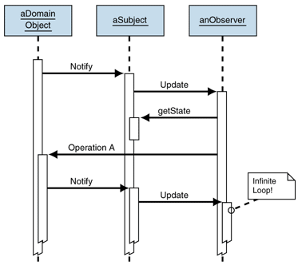
Figure 7: Modifying object state from within Update causes an infinite loop
In this example, the observer performs Operation A in response to the state change notification. If Operation A changes the state of DomainObject, it then triggers another call to Notify(), which in turn calls the Update method of the observer again. This results in an infinite loop. The infinite loop is easy to spot in this simple example, but if relationships are more complicated, it may be difficult to determine the dependency chain. One way to reduce the likelihood of infinite loops is to make the notification interest-specific. For example, in C#, use the following interface for subject, where Interest could be an enumeration of all types of interest:

interface Subject
{
public void addObserver(Observer o, Interest a);
public void notify(Interest a);
...
}

interface Observer
{
public void update(Subject s, Interest a);
}

Allowing observers to be notified only when an event related to their specific interest occurs reduces the dependency chain and helps to avoid infinite loops. This is equivalent to defining multiple, more narrowly defined, event types in .NET. The other option for avoiding the loop is to introduce a locking mechanism to keep the subject from publishing new notifications while it is still inside the original Notify() loop.

Example
See Implementing Observer in .NET.

Resulting Context
Because Observer supports loose coupling and reduces dependencies, should you loosely couple every pair of objects that depend on each other? Certainly not. As is the case with most patterns, one solution rarely solves all problems. You need to consider the following tradeoffs when employing the Observer pattern.

Benefits
• Loose coupling and reduced dependencies. The client is no longer dependent on the observers because it is isolated through the use of a subject and the Observer interface. This advantage is used in many frameworks where application components can register to be notified when (lower-level) framework events occur. As a result, the framework calls the application component, but is not dependent on it.
• Variable number of observers. Observers can attach and detach during runtime because the subject makes no assumptions about the number of observers. This feature is useful in scenarios where the number of observers is not known at design time (for example, if you need an observer for each window that the user opens in the application).

Liabilities
• Decreased performance. In many implementations, the update() methods of the observers may execute in the same thread as the subject. If the list of observers is long, the Notify() method may take a long time. Abstracting object dependencies does not mean that adding observers has no impact on the application.
• Memory leaks. The callback mechanism (when an object registers to be called later) used in Observer can lead to a common mistake that results in memory leaks, even in managed C# code. Assuming that an observer goes out of scope but forgets to unsubscribe from the subject, the subject still maintains a reference to the observer. This reference prevents garbage collection from reallocating the memory associated with the observer until the subject object is destroyed as well. This can lead to serious memory leaks if the lifetime of the observers is much shorter than the lifetime of the subject (which is often the case).
• Hidden dependencies. The use of observers turns explicit dependencies (through method invocations) into implicit dependencies (via observers). If observers are used extensively throughout an application, it becomes nearly impossible for a developer to understand what is happening by looking at the source code. This makes it very difficult to understand the implications of code changes. The problem grows exponentially with the levels of propagation (for example, an observer acting as Subject). Therefore, you should limit the use of observers to few well-defined interactions, such as the interaction between model and view in the Model-View-Controller pattern. The use of observers between domain objects should generally be cause for suspicion.
• Testing/Debugging difficulties. As much as loose coupling is a great architectural feature, it can make development more difficult. The more you decouple two objects, the more difficult it becomes to understand the dependencies between them when looking at the source code or a class diagram. Therefore, you should only loosely couple objects if you can safely ignore the association between them (for example, if the observer is free of side effects).

Related Patterns
For more information, see Implementing Observer in .NET.

Acknowledgments
[Gamma95] Gamma, Helm, Johnson, and Vlissides. Design Patterns: Elements of Reusable Object-Oriented Software. Addison-Wesley, 1995.

